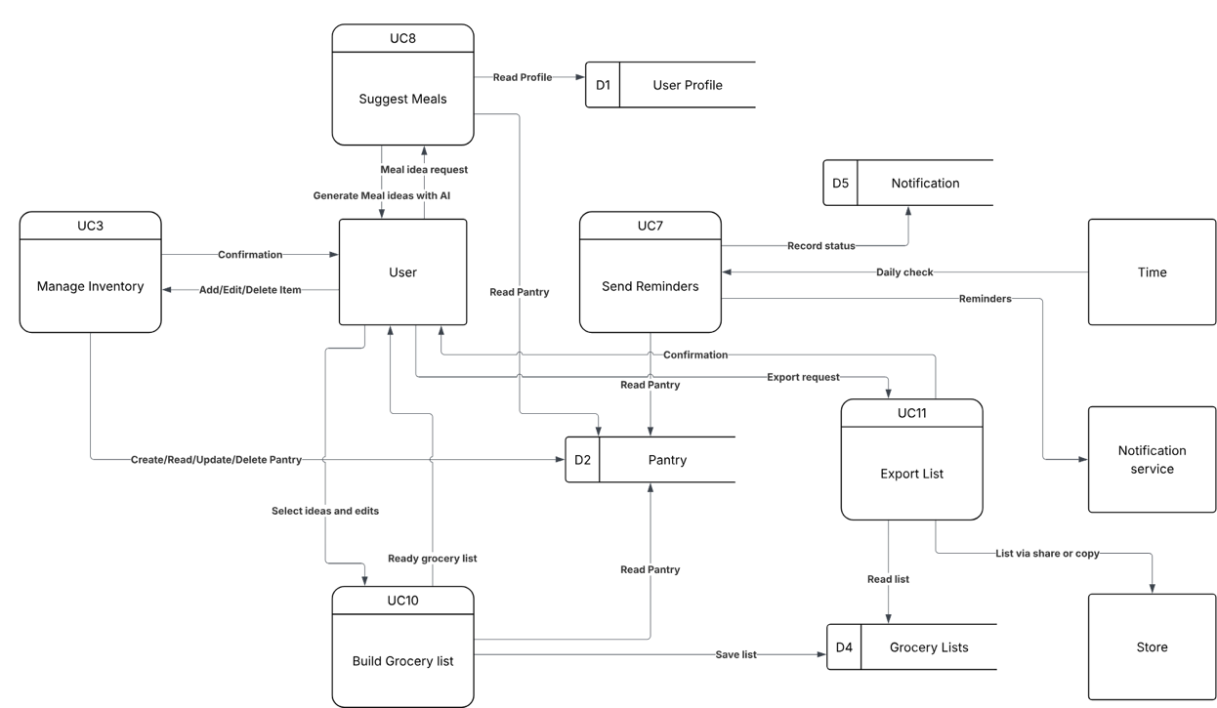
Level 0 Logical Diagram
Level 0 Physical Diagram
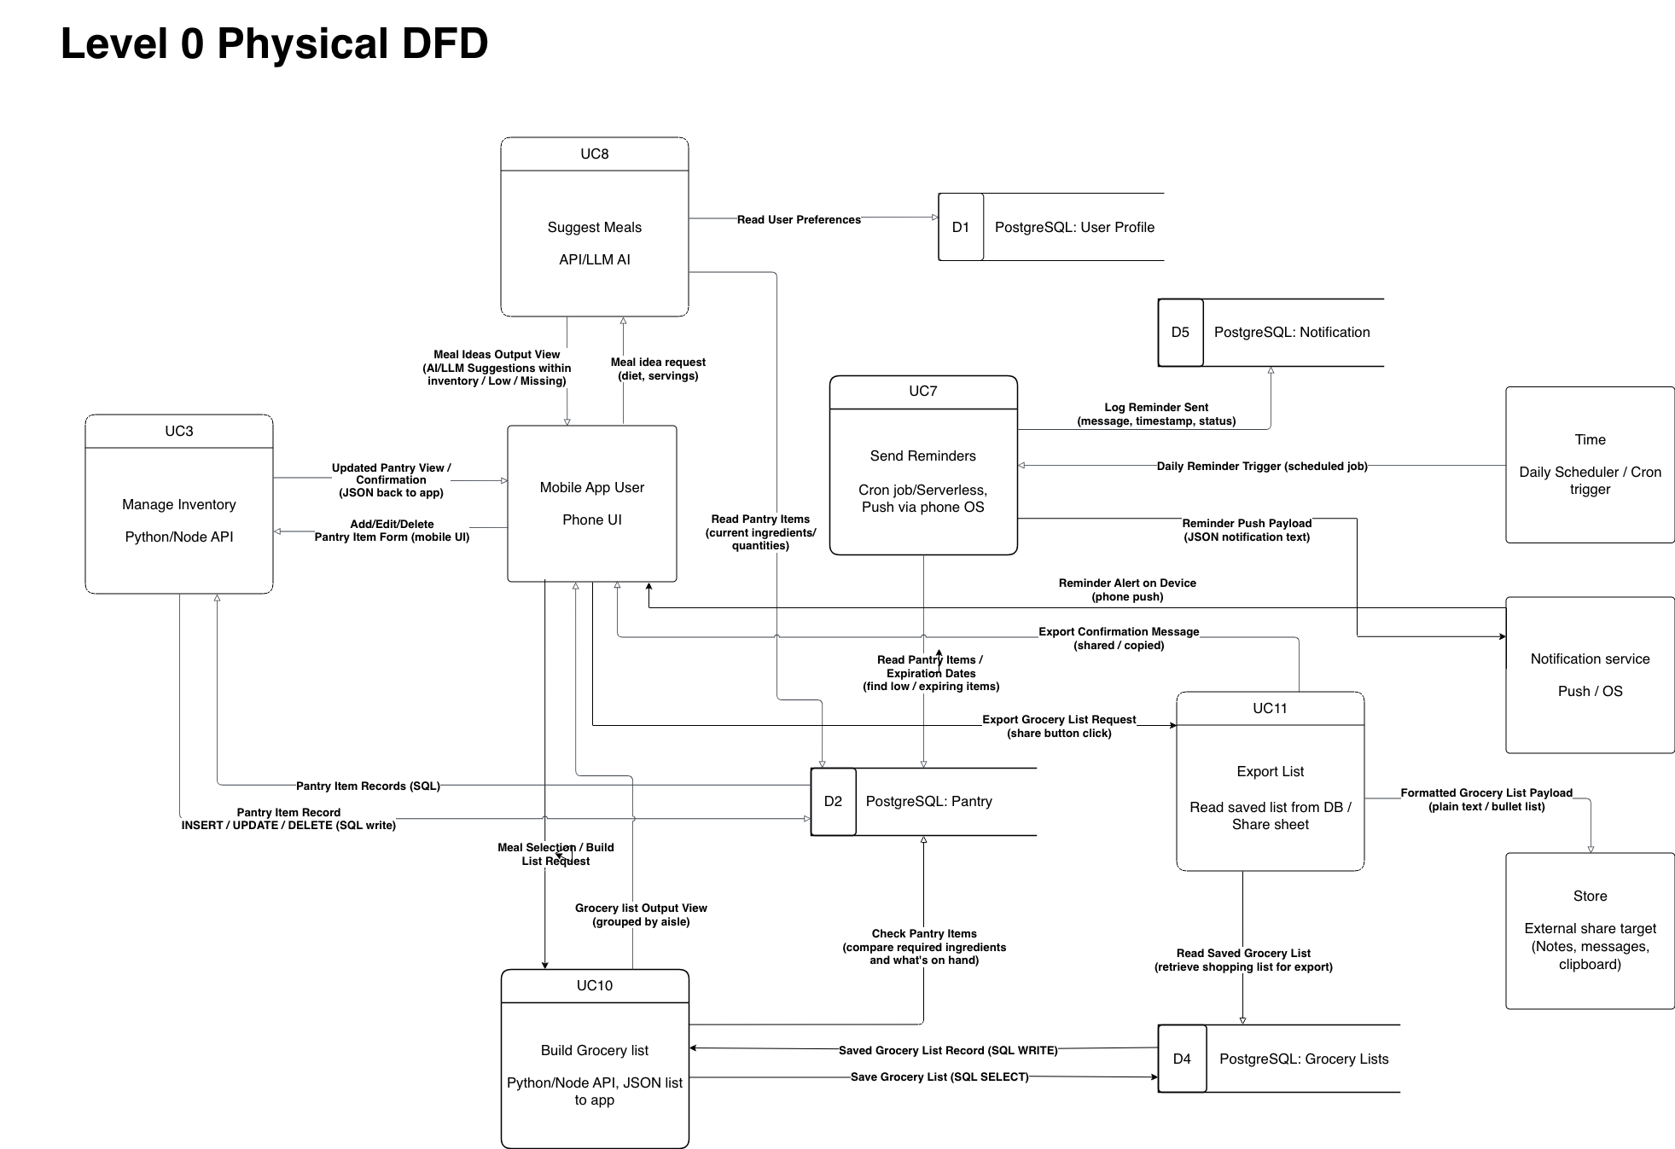
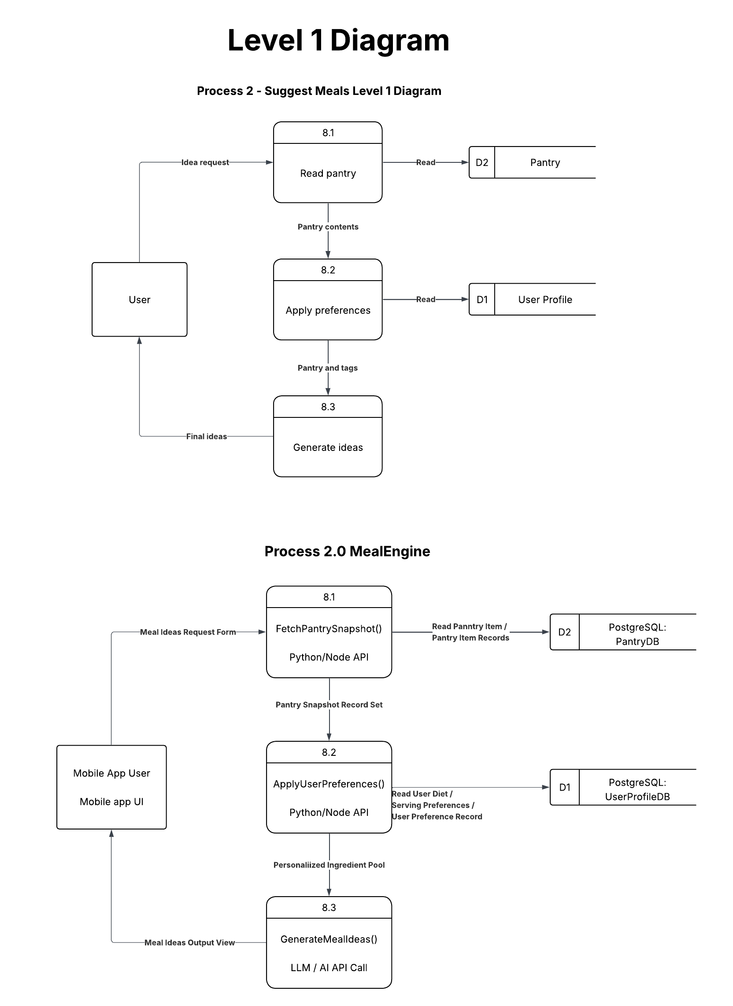
Level 1 Logical Diagram

Level 1 Physical Diagram

Structure Chart (Level 0)

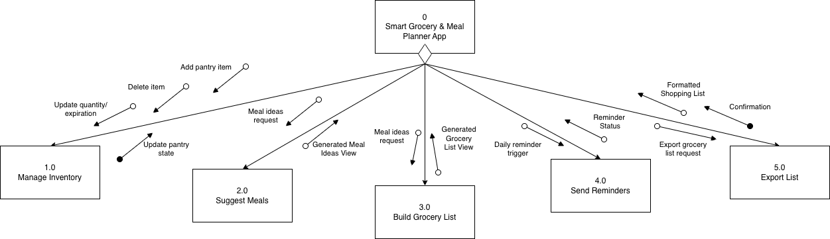

Structure Chart (Level 1)

